
Name | ID
Mostafa Ahmed abd el Monem | 23P0423
Ahmed elbaramawy | 24P0203
Hassan Ahmed Hassan Khalaf | 2200281
Omar Khaled Aly Ibrahim Gaballa | 22P0238
Ahmed Khaled Ahmed | 24P0133

Acknowledgment
We are extremely privileged and indebted to all the support, supervision, assistance and guidelines that we are receiving throughout the project. Firstly, we owe our deep gratitude to the Department of Mechatronics Engineering, Ain Shams University for providing this chance to do the project. Then with all due respect, special thanks to our supervisor, Dr. Shady Ahmed Maged Ahmed Mohamed for providing the necessary guidance. We welcome constructive comments and suggestions that will help us do better in the future. It is our radiant sentiment to place on record our kindest regards whoever were directly and indirectly involved in the successful completion of this project

ABSTRACT
This project presents a fully functioning model of an electromechanical kid's toy enhances entertainment and engagement through interactive gameplay, suitable for the age group between 2-10 years old. The toy incorporates 10 balls, evenly split between two teams, with 5 white balls and 5 black balls. Gameplay begins upon powering the system, where balls are fed into two adjustable cannons. Players can control the cannon movement to aim at a target. Infrared sensor detects the ball's color upon successfully entering the basket, relaying information to the first microcontroller which will actively participate by announcing when a player scores, creating an interactive and engaging experience. , and simultaneously to the second microcontroller for updating the LCD screen display. Missed shots and scored balls are collected in a designated lane and lifted using an Archimedes screw mechanism. A secondary infrared sensor identifies the ball color, transmitting the data to the microcontroller, which directs a servo motor to sort the balls appropriately. The process repeats, ensuring smooth and continuous operation of the system. This setup highlights the integration of mechanical, electronic, and software components to deliver a user-friendly and interactive experience. Moreover, theoretical calculations for torque, power and projectile-based shooting mechanism were calculated to choose the suitable motor in each sub-system. The parts are designed using Inventor 2024 and printed on 3d printer or on laser cut machine. The integration of interactive gameplay features (like cannon aiming and scoring), realtime feedback via LCD and mobile applications, and modular design for easy maintenance sets it apart from conventional toys. Its use of eco-friendly materials (such as PLA filament) aligns with the growing consumer demand for sustainable products. The modular design not only simplifies maintenance but also supports scalability, making the toy viable for mass production in the future.

Contents
1 Introduction
2 Work Breakdown Structure(WBS)
3 GANTT Chart
4 PDS (Product Design Specifications)
5 Whole System Flowchart
6 Whole System Block Diagram
7 Wiring Diagram for each subsystem
8 PCB Design Schematic
8Lifting
  - CAD Design full assembly
8.2 Actuator sizing calculations
- Shooting
9.1 CAD Design full assembly
9.2 Actuator sizing calculations
10 Sorting
10.1 CAD design full assembly
10.2 Actuator sizing calculations
11 Mobile app
12 Conclusion

Introduction
This report explores the design and development of an electromechanical interactive toy aimed at engaging children aged 2–10 years. The project integrates mechanical, electrical, and software systems to provide an immersive and educational experience. The toy features a game where players control adjustable cannons to shoot balls into a basket, fostering skills like hand-eye coordination and strategic thinking. The toy incorporates multiple subsystems: Cannon System: Adjustable cannons allow players to aim and shoot balls towards a target basket. Ball Collection and Lifting Mechanism: Missed and scored balls are collected and lifted using an Archimedes screw mechanism. Sorting Mechanism: Infrared sensors detect the color of balls and a sorting system classifies them accordingly. Scoreboard and Interface: Scores are updated in real-time on both an LCD screen and a mobile application. The design prioritizes safety, user-friendly ergonomics, energy efficiency, and environmental sustainability. By utilizing advanced tools such as Autodesk Inventor Professional 2025 for 3D modeling, Fritzing for PCB design, and Arduino for programming, the project exemplifies the application of mechatronics principles in an interactive children's toy.

Work Breakdown Structure
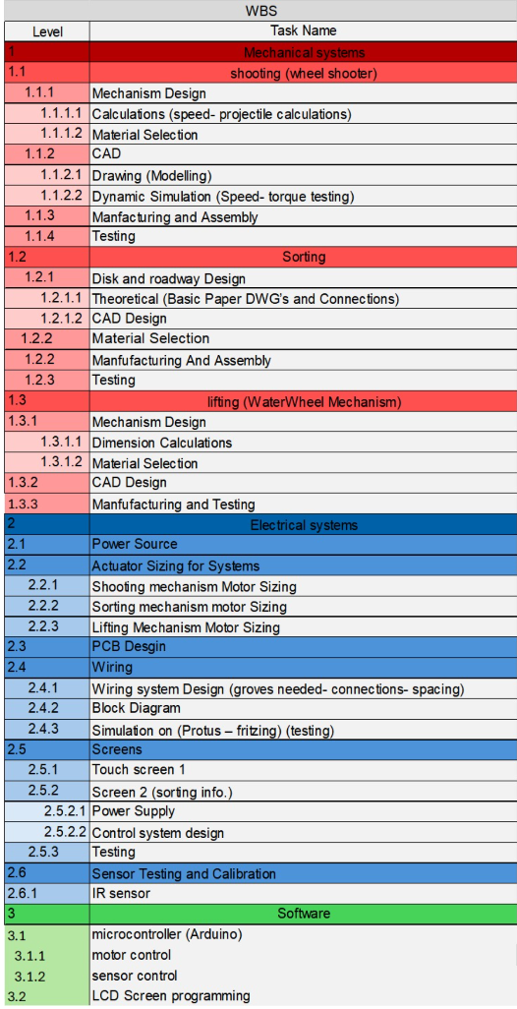
Gantt Chart
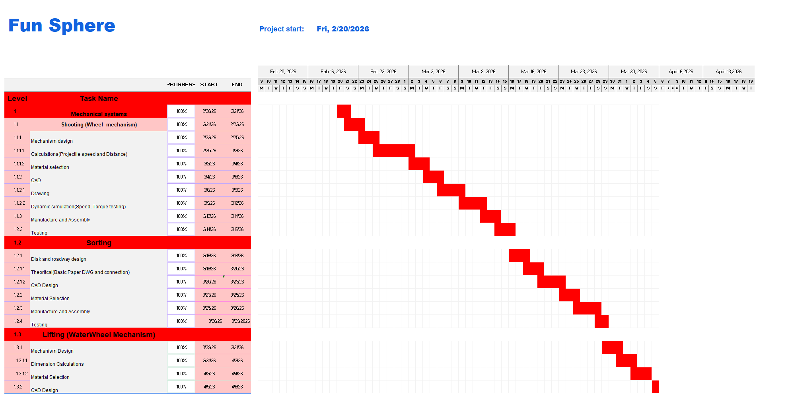
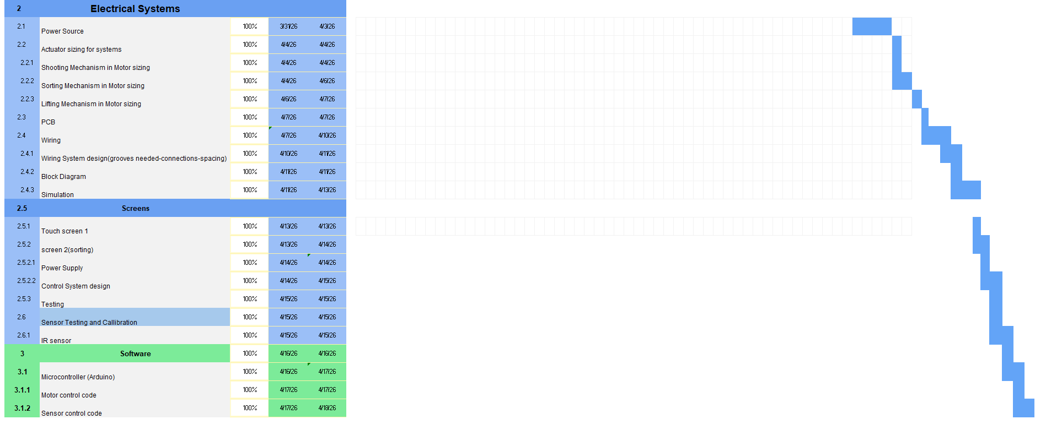

PDS (Product Design Specifications)

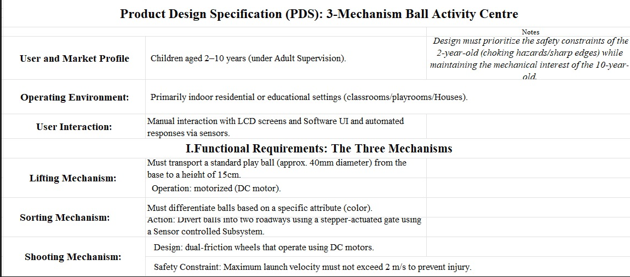
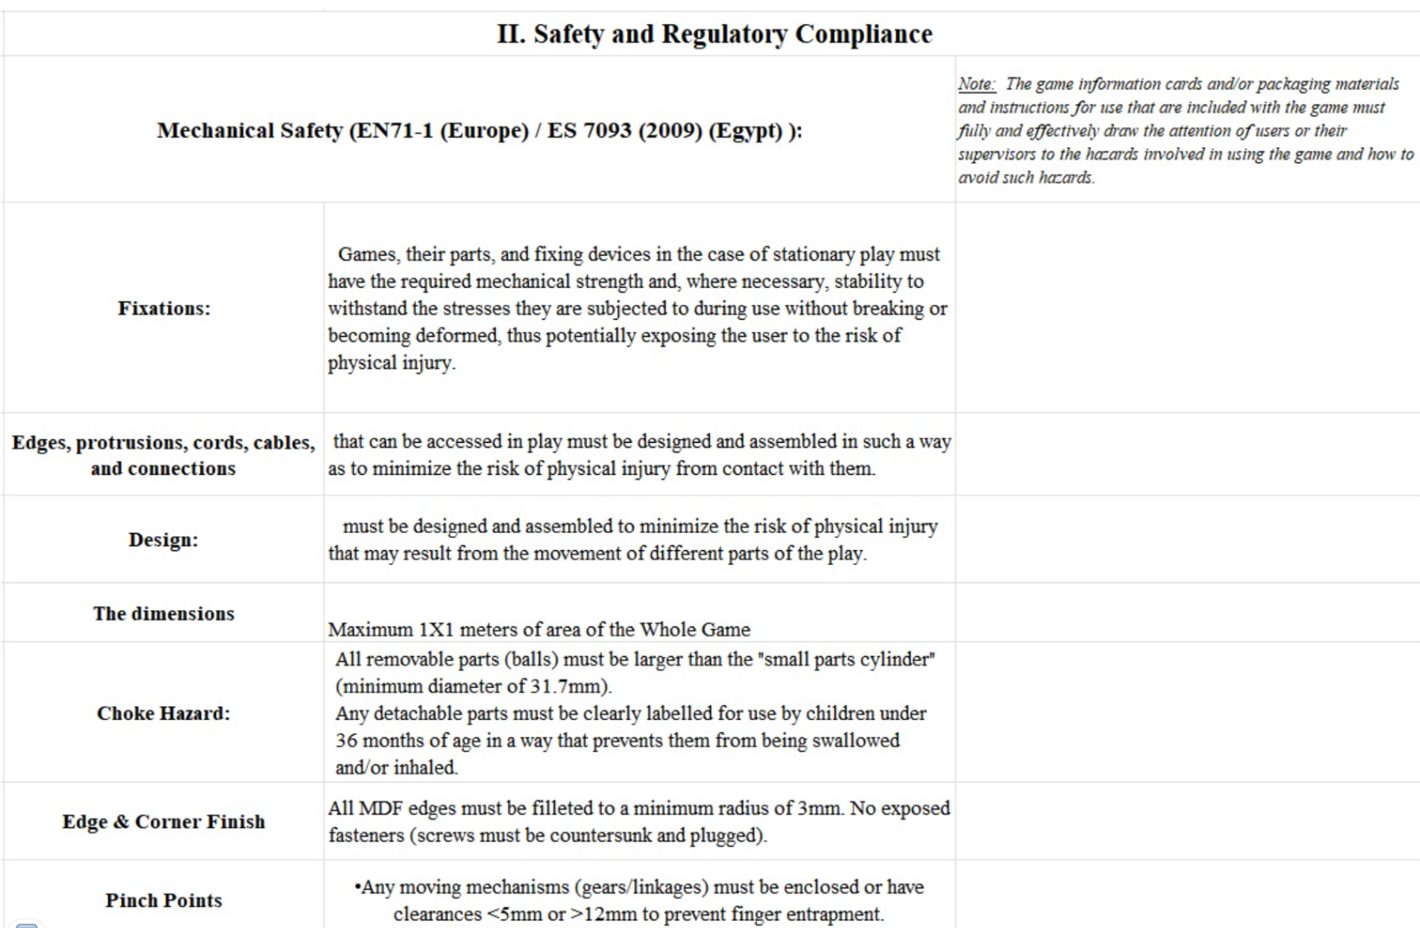

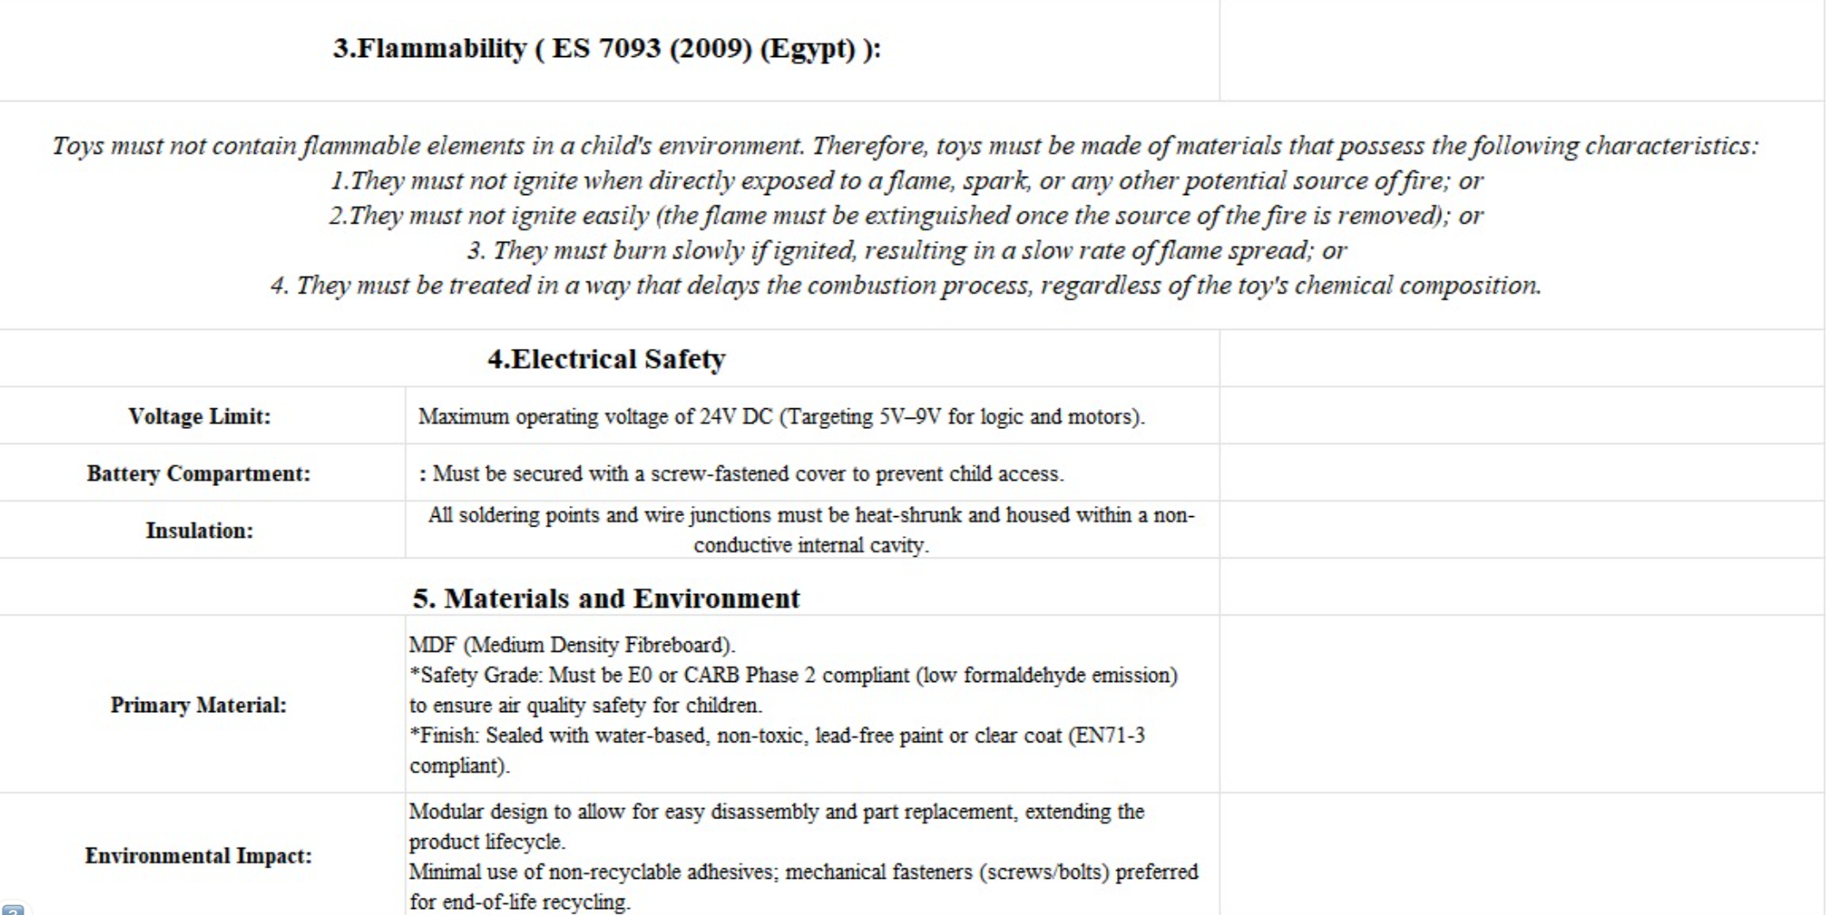

Whole System Flowchart
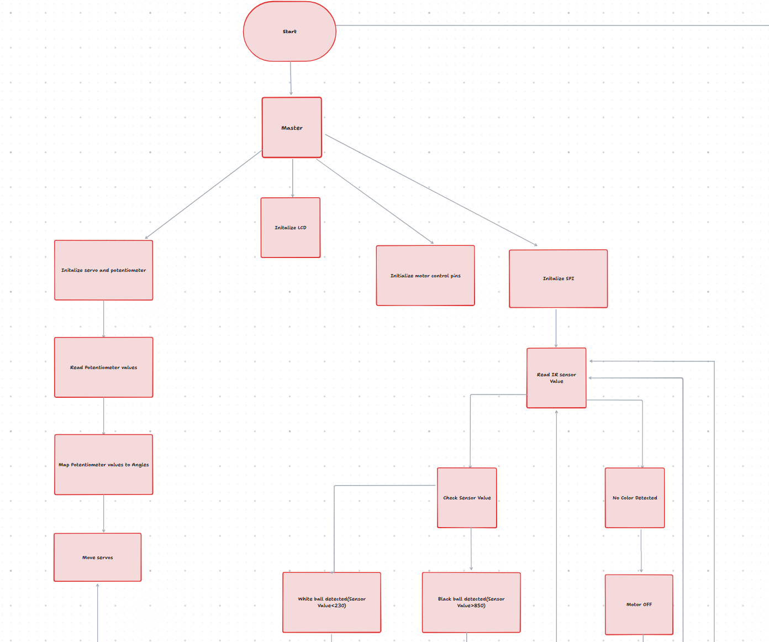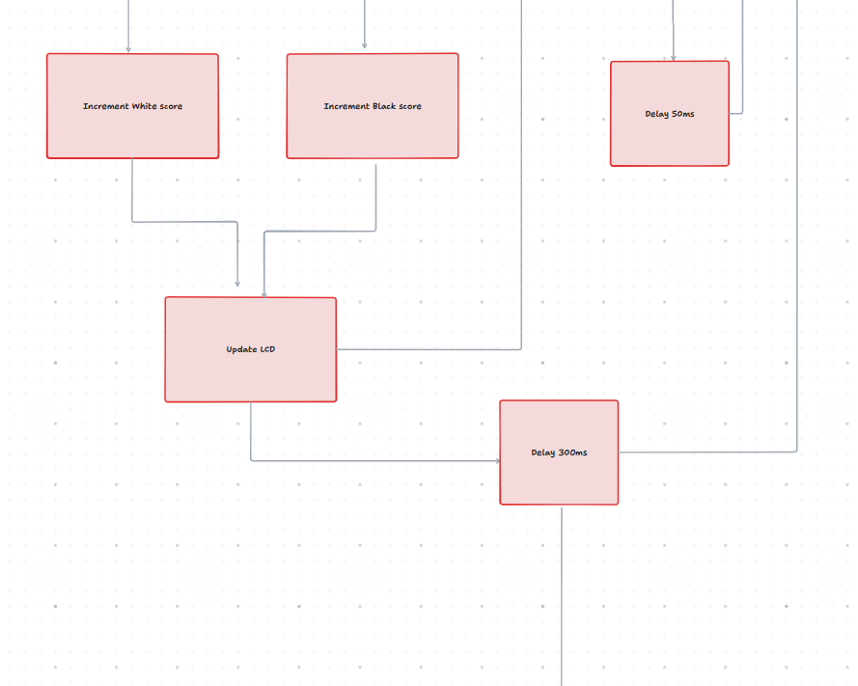
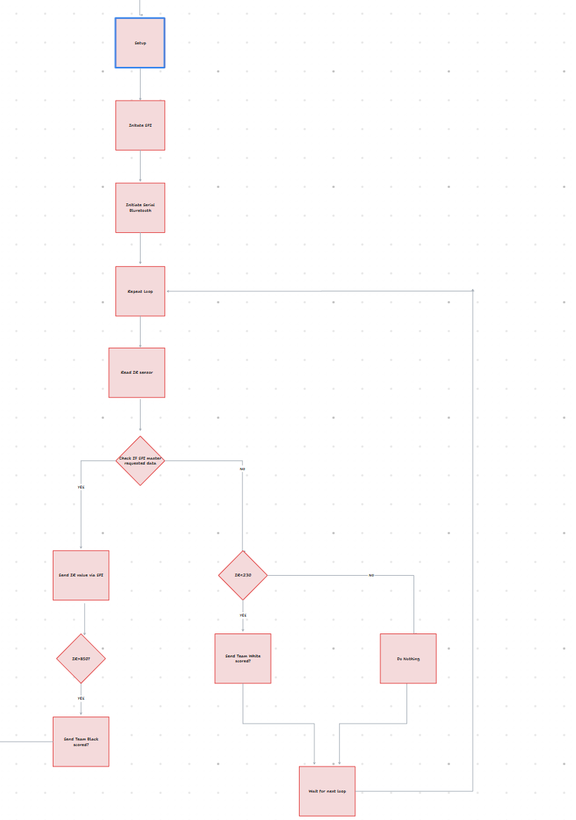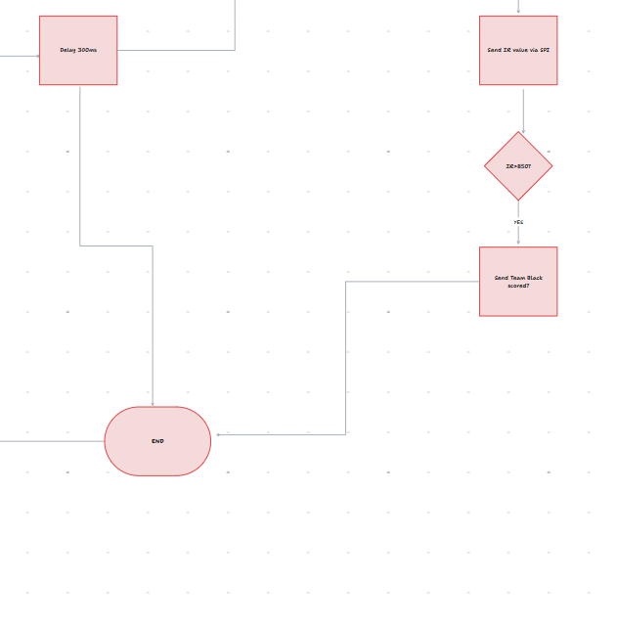
Link https://app.clickup.com/90152509611/v/wb/2kyr485b-695

Whole System Block Diagram
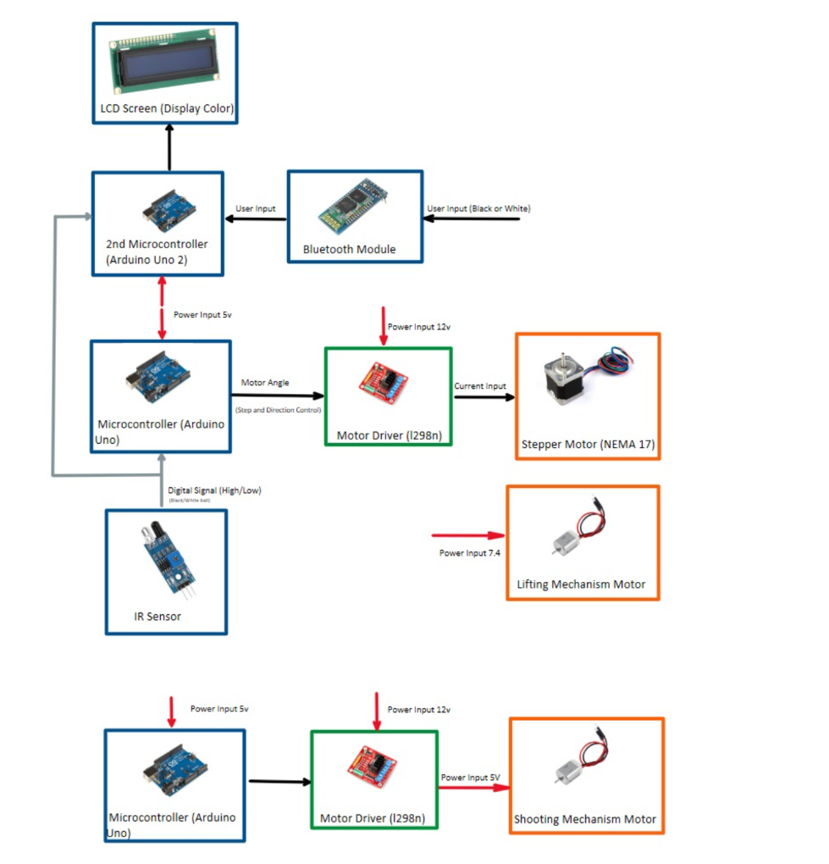

Wiring Diagram for each subsystem
Lifting
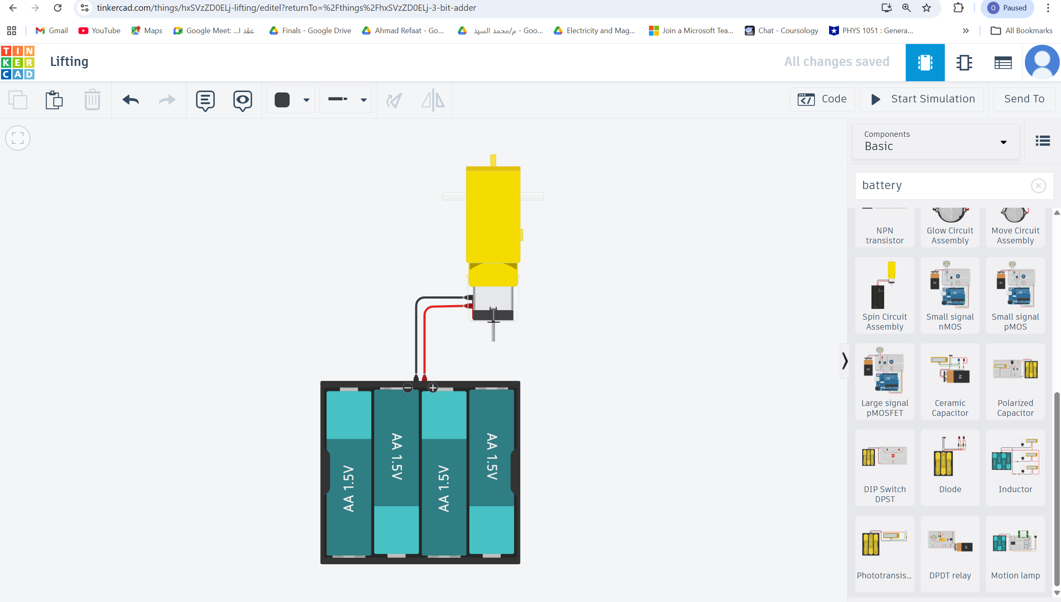
Shooting
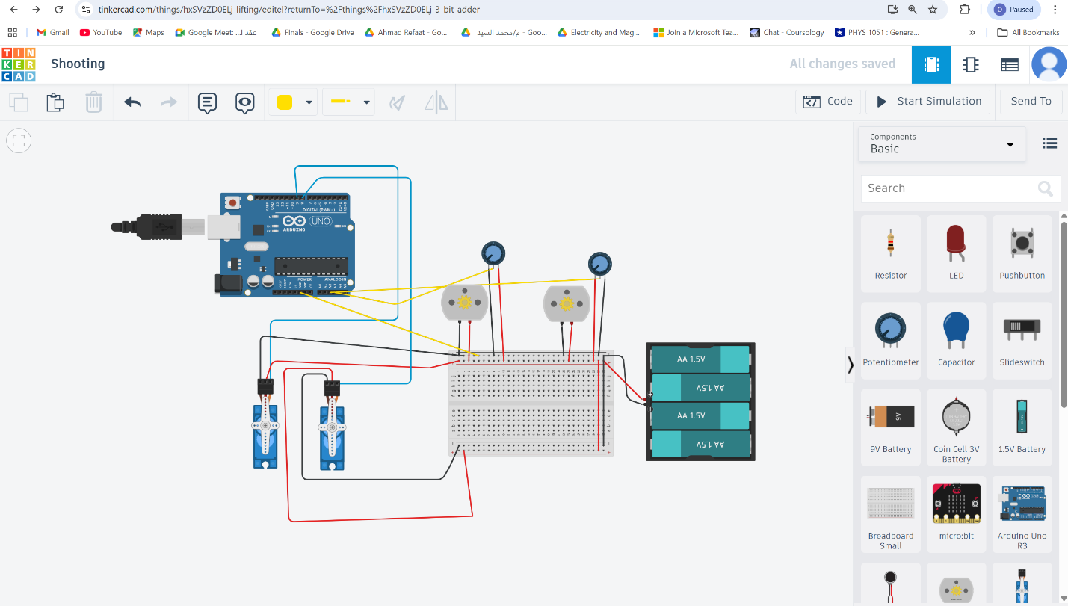
Link
https://www.tinkercad.com/things/hxSVzZD0ELj-shooting/editel?returnTo=https%3A%2F%2Fwww.tinkercad.com%2Fdashboard
Sorting
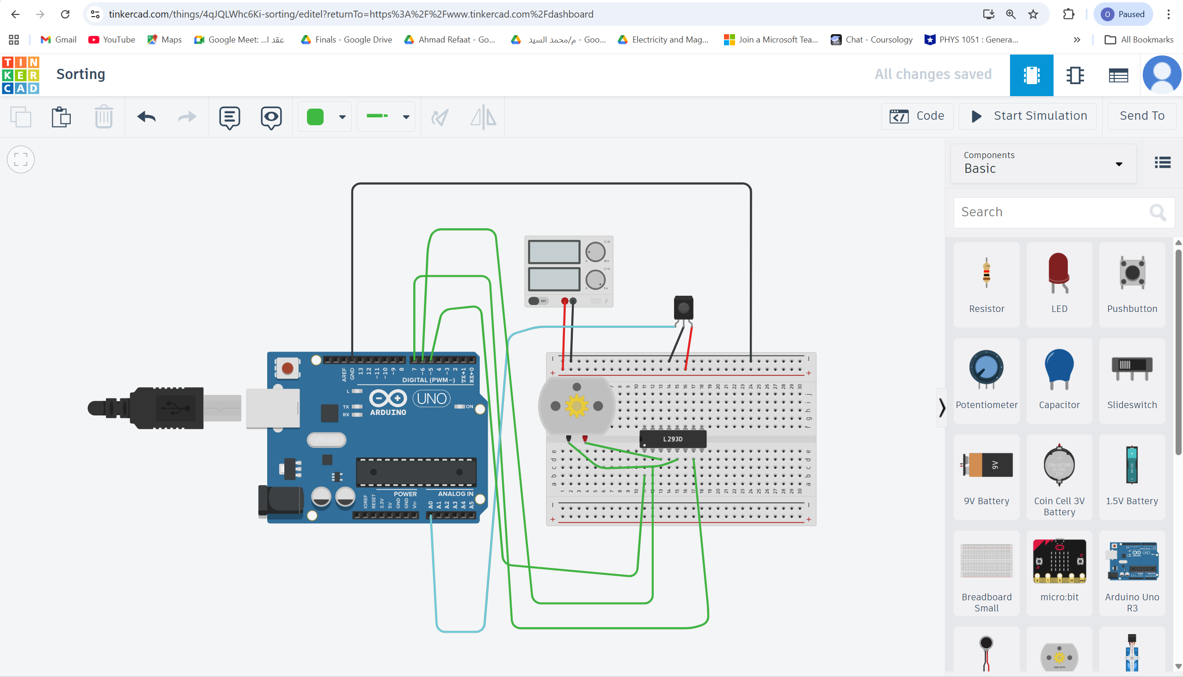
Link
https://www.tinkercad.com/things/4qJQLWhc6Ki-sorting/editel?returnTo=https%3A%2F%2Fwww.tinkercad.com%2Fdashboard

PCB Design Schematic Picture
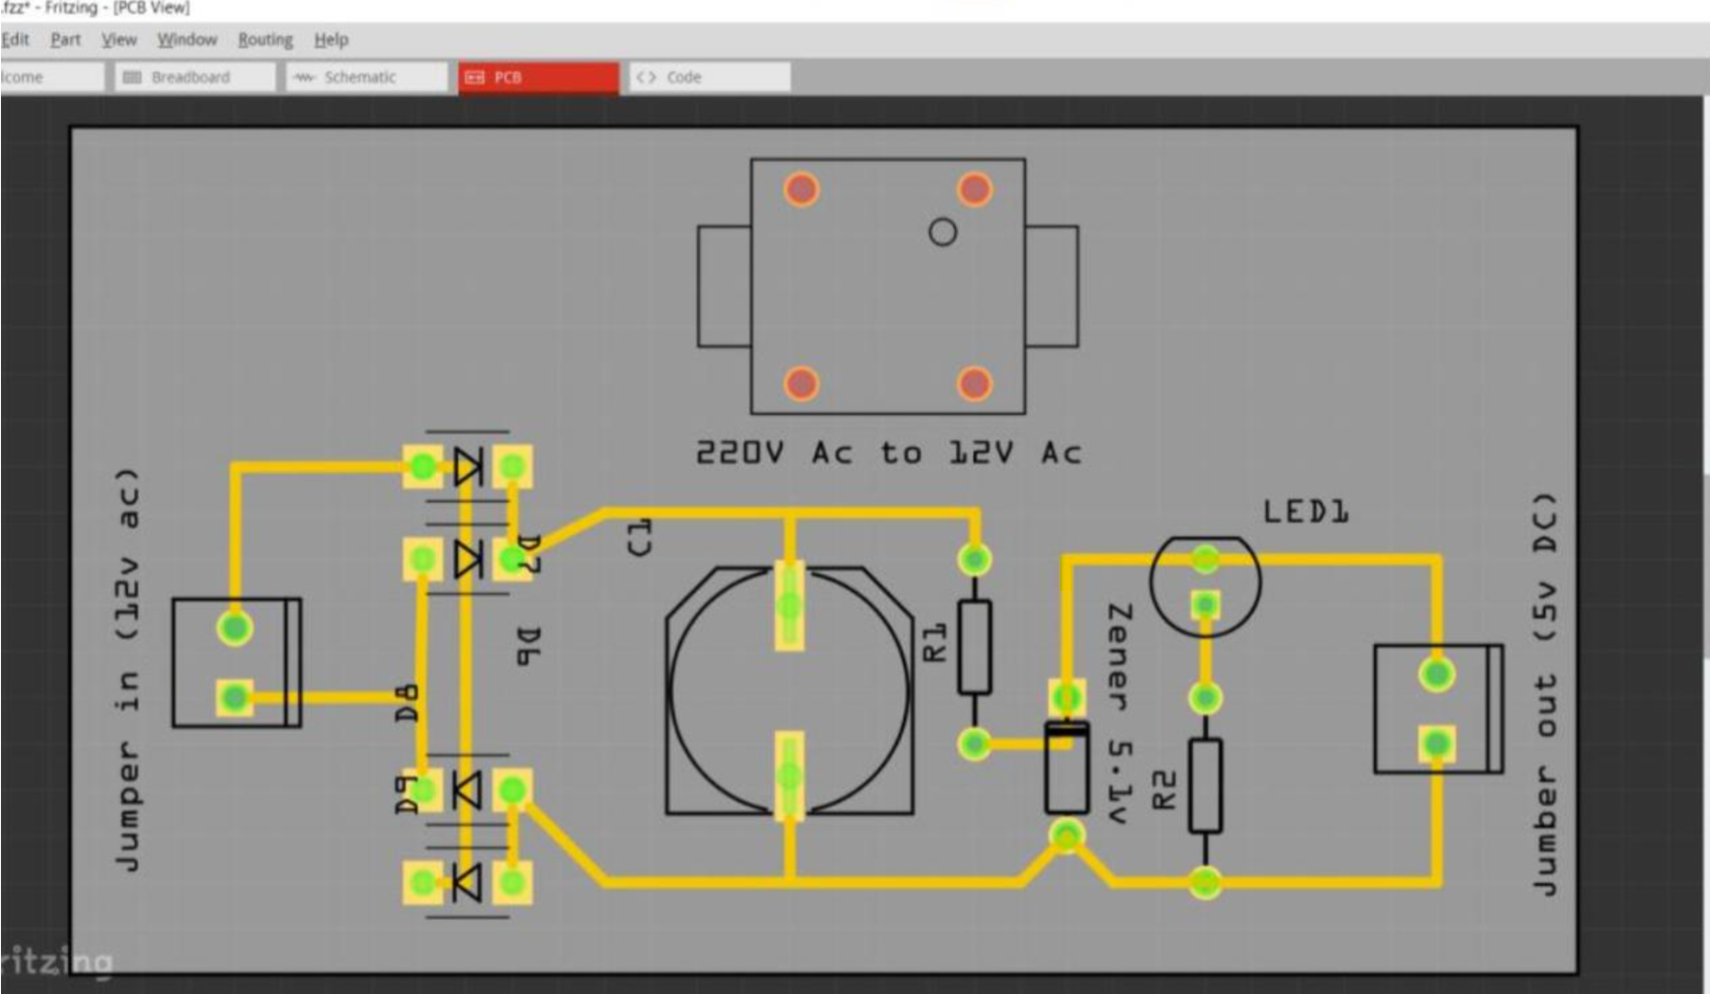

Lifting
CAD Design
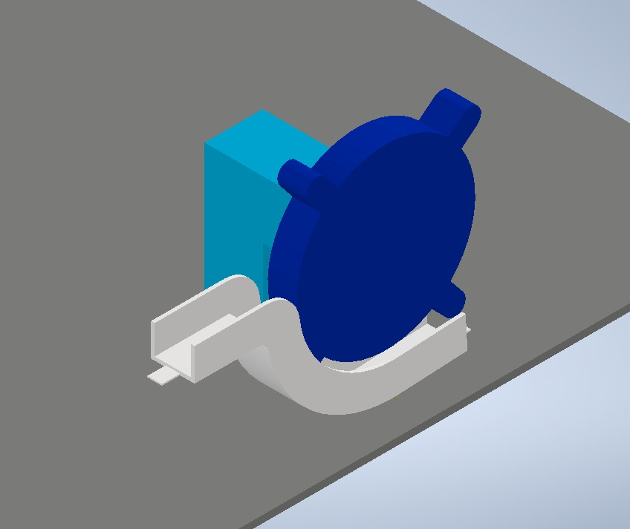
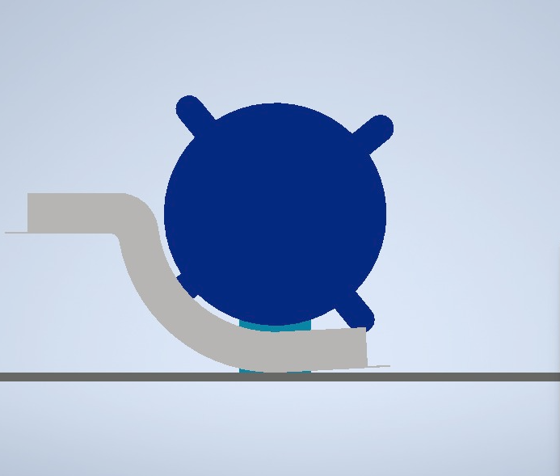

Actuator sizing calculations
Given Data
• Angular acceleration: 𝛼 = 12.57 rad/s2
• Mass moment of inertia: 𝐽 = 0.001718 kg\m2
• Density: 𝜌 = 750 kg/m3
• Thickness: 𝑡 = 0.005 m
• Main disk diameter: 𝐷 = 0.245 m ⇒ 𝑅 = 0.1225 m
• Tabs: 4 tabs, each = rectangle 30 × 30 mm+ semicircle of diameter 30 mm
1. Geometry & Volume
Disk volume:
$$V_{disk}=πR^{2}t=π({0.1225}^{2})(0.005)≈2.35×{10}^{-4} {\text{m}}^{3}$$
Tab volume (per tab):
- Rectangle: $V_{rect}=0.03⋅0.03⋅0.005=4.5×{10}^{-6} {\text{m}}^{3}$
- Semicircle: $V_{semi}=\frac{1}{2}π({0.015}^{2})(0.005)≈1.77×{10}^{-6} {\text{m}}^{3}$
- Total per tab: $V_{tab}≈6.27×{10}^{-6} {\text{m}}^{3}$
For 4 tabs:
$$V_{tabs}=4⋅6.27×{10}^{-6}≈2.51×{10}^{-5} {\text{m}}^{3}$$

Total volume:
$$V_{total}=V_{disk}+V_{tabs}≈2.35×{10}^{-4}+2.51×{10}^{-5}=2.60×{10}^{-4} {\text{m}}^{3}$$
2. Mass
$$m=ρ⋅V_{total}=750⋅2.60×{10}^{-4}≈0.195\text{ kg}$$
3. Inertia Check
$$J_{disk}=\frac{1}{2}m_{disk}R^{2}=\frac{1}{2}(0.176)({0.1225}^{2})≈0.00132 {\text{kg\backslash m}}^{2}$$
4. Torque Calculation
General equation:
$$T_{m}=J⋅α$$
$$T_{m}=0.001718⋅12.57≈0.0216\text{ N.m}$$
Motion Profile Analysis (Trapezoidal 1/3 – 1/3 – 1/3)
1. Timing
- Acceleration phase: $t_{a}=\frac{1}{3}⋅1=0.333\text{ s}$
- Constant speed phase: $t_{c}=0.333\text{ s}$
- Deceleration phase: $t_{d}=0.333\text{ s}$
- Dwell time: $t_{dwell}=2\text{ s}$
- Total cycle time: $T=3\text{ s}$

2. Angular Displacement
linear displacement of $x=0.4\text{ m}$. With radius $r=0.1225\text{ m}$:
$$θ_{total}=\frac{x}{r}=\frac{0.4}{0.1225}≈3.27\text{ rad}$$
3. Maximum Angular Velocity
$$θ_{total}=ω_{max}\left(\frac{t_{a}}{2} + t_{c} + \frac{t_{d}}{2}\right)$$
$$θ_{total}=ω_{max}(0.1665+0.333+0.1665)=ω_{max}⋅0.666$$
$$ω_{max}=\frac{3.27}{0.666}≈4.91\text{ rad/s}$$
4. Angular Acceleration
$$α=\frac{ω_{max}}{t_{a}}=\frac{4.91}{0.333}≈14.75 {\text{rad/s}}^{2}$$
5. Torque per Phase
General equation:
$$T_{m}=J⋅α+T_{load}$$
Here:
- $J=0.001718 {\text{kg\backslash m}}^{2}$
A) Acceleration Phase
$$T_{acc}=J⋅α=0.001718⋅12.57≈0.0216\text{ N.m}$$

B) Constant Velocity Phase
$$T_{const}=T_{load}≈0$$
C) Deceleration Phase
$$T_{dec}=J⋅\left(-α\right)=-0.0216N.m$$
6. Peak Torque
$$T_{peak}=0.0216\text{ N.m}$$
7. RMS Torque
$$T_{rms}=\sqrt{\frac{1}{T}\left(t_{a}⋅T_{acc}^{2}+t_{c}⋅T_{const}^{2}+t_{d}⋅T_{dec}^{2}+t_{dwell}⋅T_{const}^{2}\right)}$$
$$T_{rms}=\sqrt{\frac{1}{3}\left(0.333⋅(0.0216)^{2}+0.333⋅0^{2}+0.333⋅(0.0216)^{2}+2⋅0^{2}\right)}$$
$$T_{rms}=\sqrt{\frac{1}{3}⋅(0.333⋅0.000467+0.333⋅0.000467)}=\sqrt{\frac{1}{3}⋅0.000311}=\sqrt{0.000104}≈0.0102\text{ N.m}$$

Shooting
CAD Design
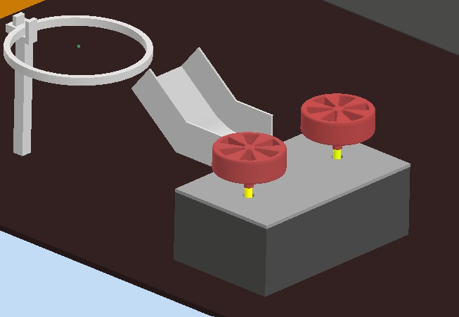

Actuator sizing calculations
Given Parameters
- Mass $m=0.015\text{ kg}$
- Radius $r=0.06\text{ m}$
- Cycle Time = $0.48\text{ s}$
- Dwell Time = $0.05\text{ s}$
Inertia Calculation
Load Inertia:
$$J_{load}=m⋅r^{2}=0.015⋅(0.06)^{2}=5.4×{10}^{-5} {\text{kg\backslash m}}^{2}$$
Motor Inertia:
$$J_{motor}=J_{load}=5.4×{10}^{-5} {\text{kg\backslash m}}^{2}$$
Total Inertia (with gearbox efficiency $η=0.85$):
$$J_{total}=J_{load}+\frac{J_{motor}}{η}=5.4×{10}^{-5}+\frac{5.4×{10}^{-5}}{0.85}=1.175×{10}^{-4} {\text{kg\backslash m}}^{2}$$
Motion Profile
Rotation angle:
$$θ_{total}={120}^{∘}=\frac{120π}{180}=2.094\text{ rad}$$

Phase times (acceleration, constant, deceleration):
$$t_{acc}=t_{const}=t_{dec}=0.14\text{ s}$$
Angular Velocity
Equation:
$$θ_{total}=\frac{1}{2}ω_{max}t_{acc}+ω_{max}t_{const}+\frac{1}{2}ω_{max}t_{dec}$$
Substitute values:
$$2.094=ω_{max}⋅(0.07+0.14+0.07)=ω_{max}⋅0.28$$
$$ω_{max}=\frac{2.094}{0.28}=7.48\text{ rad/s}$$
Angular Speed:
$$7.48\text{ rad/s}≈71.5\text{ RPM}$$
Angular Acceleration
$$α=\frac{ω_{max}}{t_{acc}}=\frac{7.48}{0.14}=53.43 {\text{rad/s}}^{2}$$
Torque Calculations
Acceleration Torque:
$$T_{acc}=\frac{J_{total}⋅α}{η}=\frac{1.175×{10}^{-4}⋅53.43}{0.85}=0.00737\text{ Nm}$$
Deceleration Torque:
$$T_{dec}=-0.00737\text{ Nm}$$
Speed Torque:
$$=0(\text{no load torque considered})$$
RMS Torque
Formula:
$$T_{rms}=\sqrt{\frac{T_{acc}^{2}t_{acc}+T_{dec}^{2}t_{dec}}{t_{cycle}}}$$
Substitute values:
$$T_{rms}=\sqrt{\frac{\left({0.00737}^{2}⋅0.14+{0.00737}^{2}⋅0.14\right)}{0.48}}$$
$$T_{rms}=0.00437\text{ Nm}$$

Sorting
CAD Design
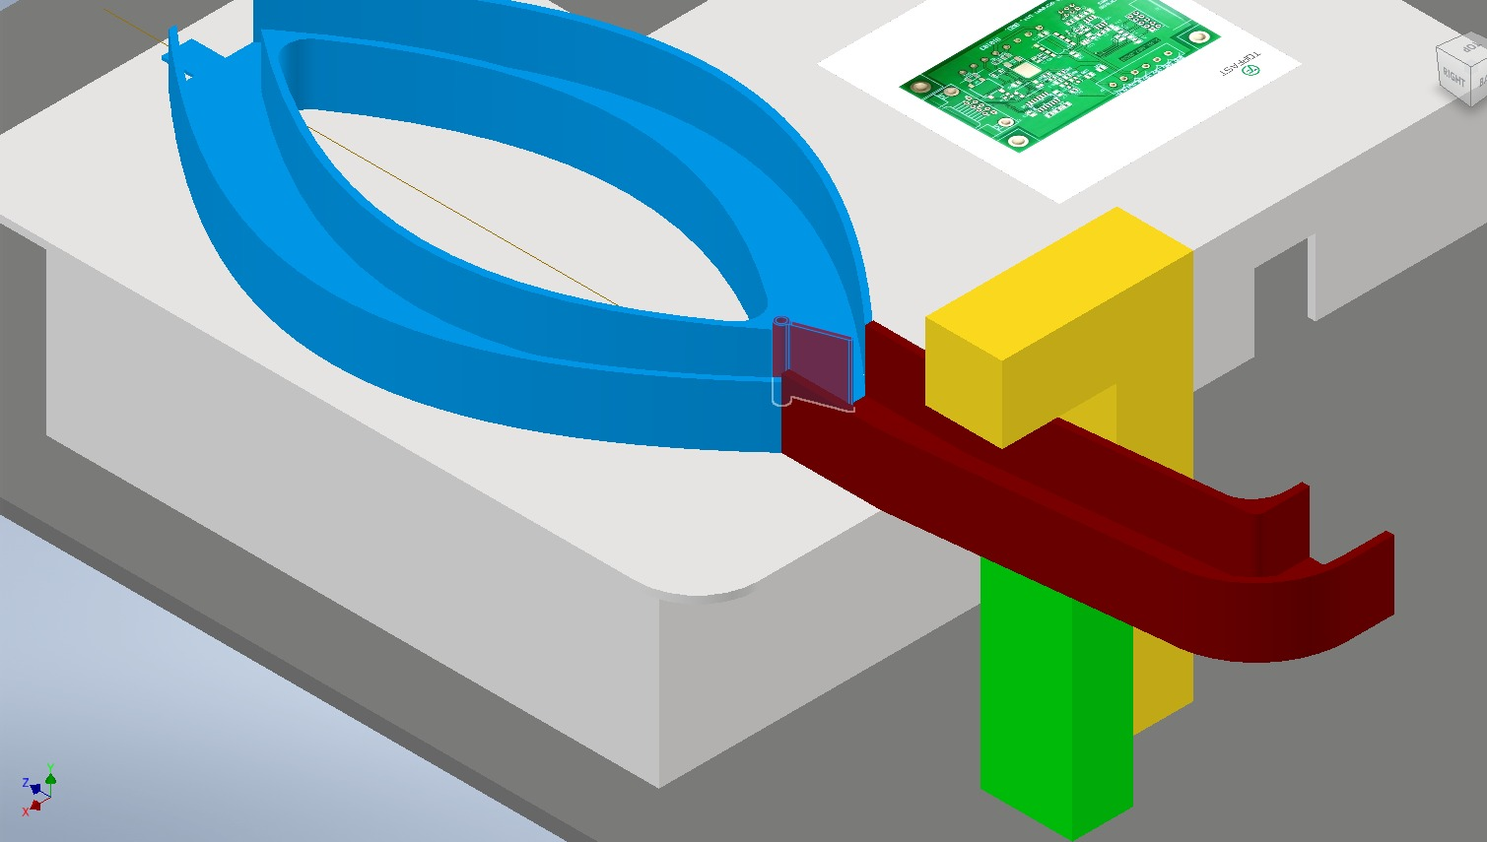


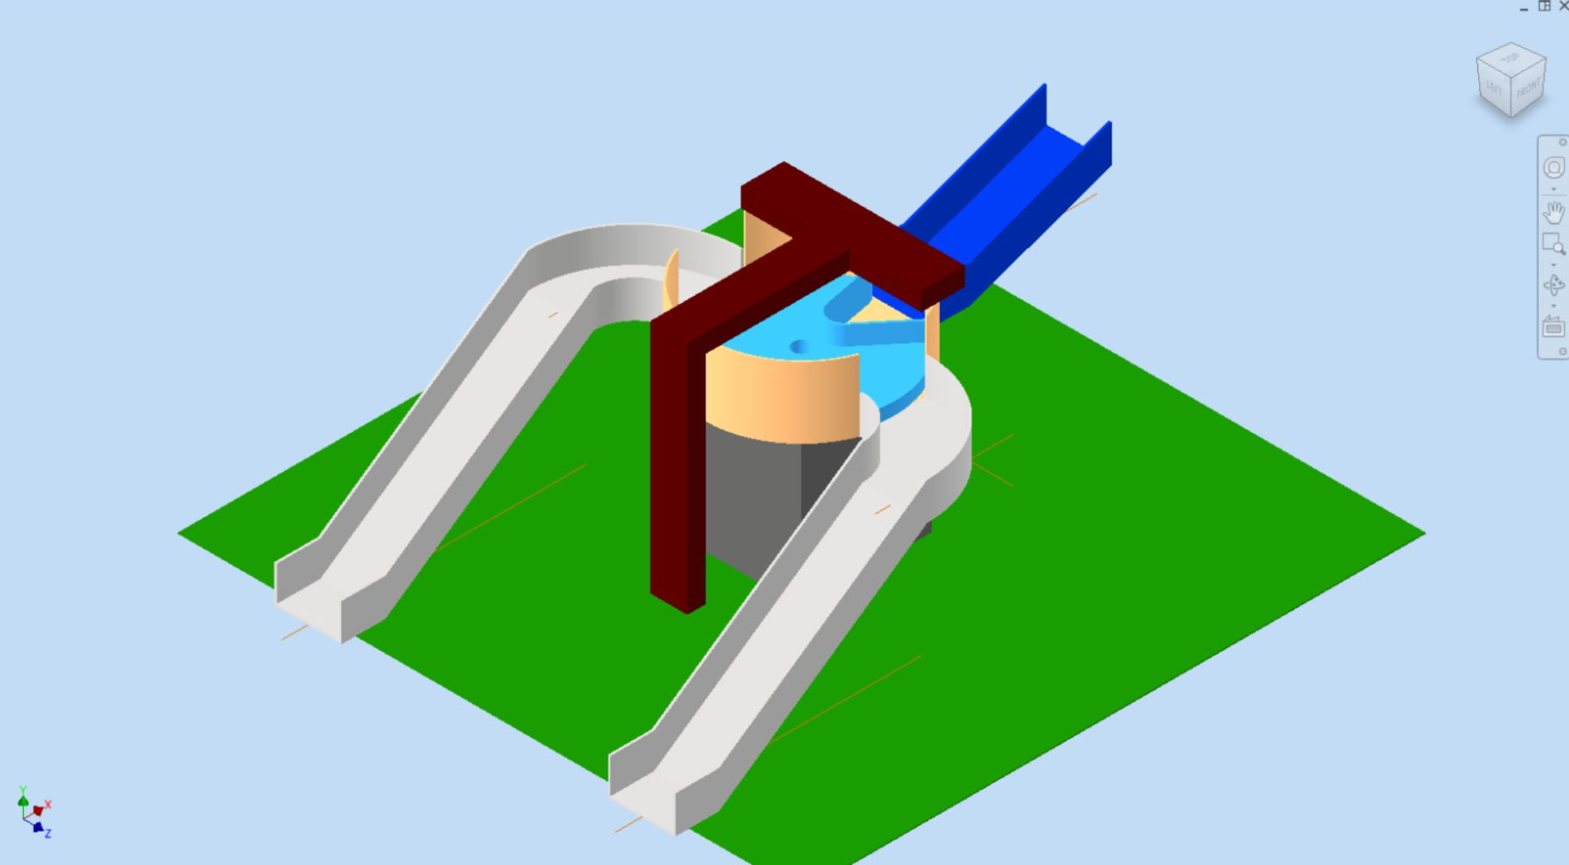

Actuator sizing calculations
1. Servo Motor Parameters
- Motor type: NEMA 17 micro servo
- Rotor radius $r=5mm$
- Mass $m=0.2\text{ kg}$
Moment of inertia of rotor:
$$J_{motor}≈0.5⋅m⋅r^{2}=0.5⋅0.2⋅(0.005)=2.5×{10}^{-6} {\text{kg\backslash m}}^{2}$$
Assume load inertia ≈ same order →
J_T = J_motor + J_load
$$J_{T}=6×{10}^{-6} {\text{kg\backslash m}}^{2}$$
2. Motion Profile (Rounded)
- Angular displacement: $Δθ=2π\text{ rad}$(one full turn)
- Total trajectory time: =6 s
- Phases:
  - Acceleration: $α_{acc}=4 {\text{rad/s}}^{2}$
  - Const velocity= 0
  - Deceleration: $α_{dec}≈-8 {\text{rad/s}}^{2}$

3. Torque Requirements
Peak torque:
$$T_{max}≈J_{T}⋅α_{max}≈6×{10}^{-6}⋅8≈5×{10}^{-5}\text{ N.m}$$
RMS torque (averaged):
$$T_{rms}=1×{10}^{-7}\text{ N.m}$$

- LCD

- Conclusion
This project successfully demonstrates the design and implementation of an interactive electromechanical toy tailored for children aged 2–10 years. The toy merges entertainment with education, allowing users to develop skills such as hand-eye coordination and problemsolving through engaging gameplay. It incorporates multiple innovative subsystems, including shooting, lifting, sorting, and scoring mechanisms, which function cohesively to create a seamless experience. In addition to its functionality, the toy adheres to ergonomic and safety standards, ensuring it is accessible and secure for children. Furthermore, its modular design enhances transportability, repairability, and sustainability by using eco-friendly materials and minimizing environmental impact.

